**Project Title:** Carpool App

**Team Members:** Billy M. Stevn H. Randy P.

**Project Description:** This app will allow user to list their car for carpool or request a car to go between GE Buckhead and Code Bootcamp or GE Alpharetta and Code Bootcamp. Drivers can list # of seats, provide the source and destination, departure time and the tool will provide an estimated time of arrival. User needing a ride can reserve a seat which will need to be accepted by the drive. Once accepted it will notify the passenger when to leave and where to meet.

App will provide Weather Maps, and Road condition between GE Buckhead and Class, or Alpharetta and Class.

If time permits it will alert for weather condition and changing road condition and update estimated time of arrival.

**Sketch of Final Product:**

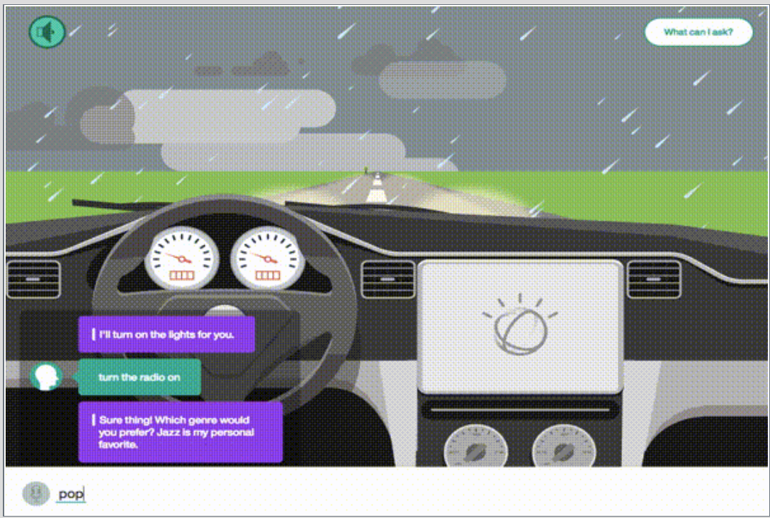

**APIs to be Used:**

**Map API’s:**

Map Quest

Google Maps (might not be free)

**Weather API’s:**

openweathermap.org

darksky

**Rough Breakdown of Tasks:**

**Randy:**

**Stephen:**

**Billy:**